**LAB ASSIGNMENT – 8.3**

Task Description#1

Use AI to generate test cases for is_valid_email(email) and then implement the validator function.

Requirements:

• Must contain @ and . characters.

• Must not start or end with special characters.

• Should not allow multiple @.

Expected Output#1

• Email validation logic passing all test cases

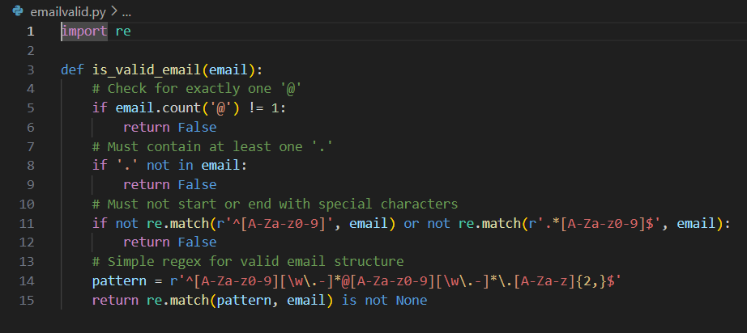

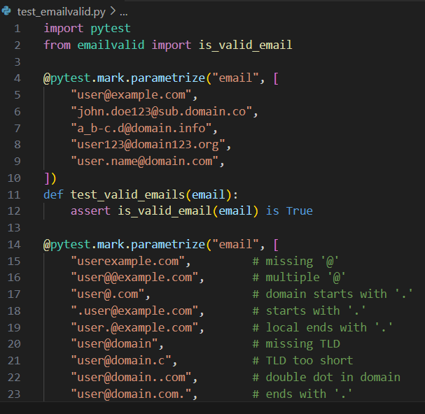

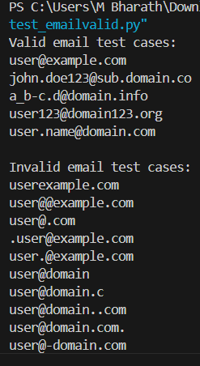

Task Description#2 (Loops)

• Ask AI to generate test cases for assign_grade(score) function. Handle boundary and invalid inputs.

Requirements

• AI should generate test cases for assign_grade(score) where: 90-100: A, 80-89: B, 70-79: C, 60-69: D, <60: F

• Include boundary values and invalid inputs (e.g., -5, 105, "eighty").

Expected Output#2

Grade assignment function passing test suite

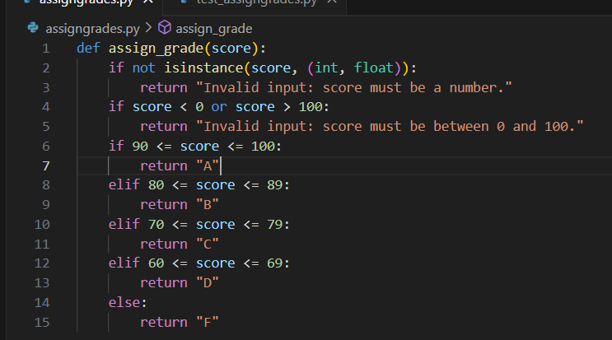

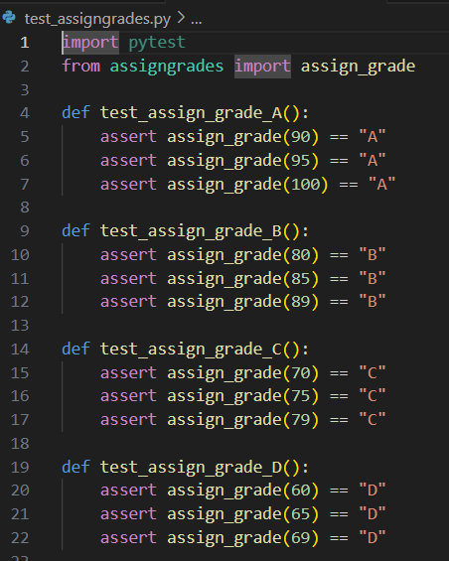

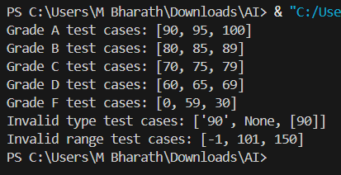

**Task Description#3**

* Generate test cases using AI for is_sentence_palindrome(sentence). Ignore case, punctuation, and spaces

**Requirement**

* Ask AI to create test cases for is_sentence_palindrome(sentence)

(ignores case, spaces, and punctuation).

* Example:

"A man a plan a canal Panama" → True

**Expected Output#3**

* Function returns True/False for cleaned sentences
* Implement the function to pass AI-generated tests.

PROMPT:

generate a python function is_sentence_palindrome(sentence). Ignore case, punctuation, and spaces and return True/False.

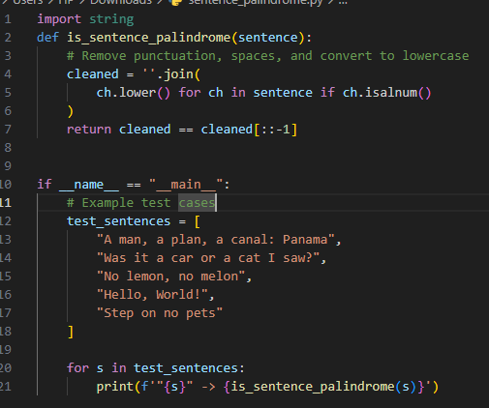

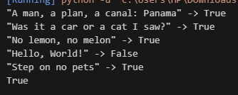

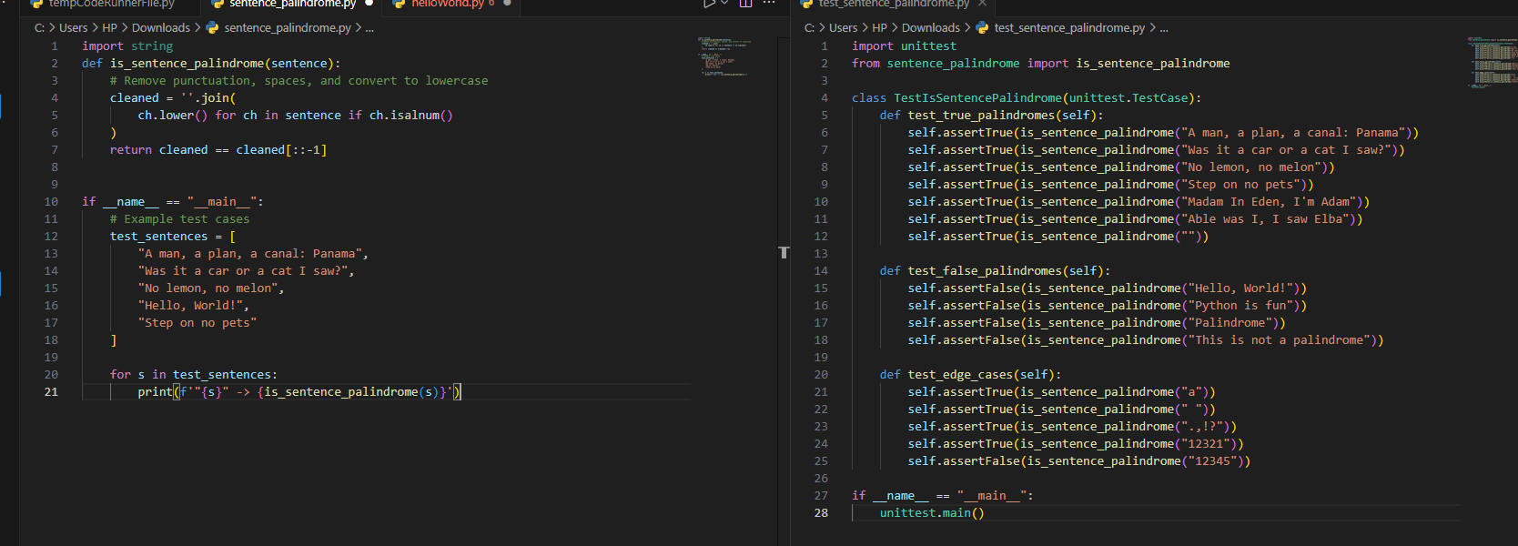

**Task Description#4**

* Let AI fix it Prompt AI to generate test cases for a ShoppingCart class (add_item, remove_item, total_cost).

**Methods:**

Add_item(name,price)

Remove_item(name)

Total_cost()

**Expected Output#4**

* Full class with tested functionalities

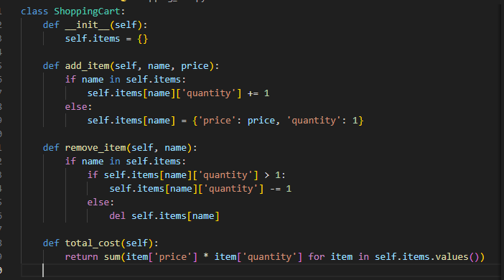

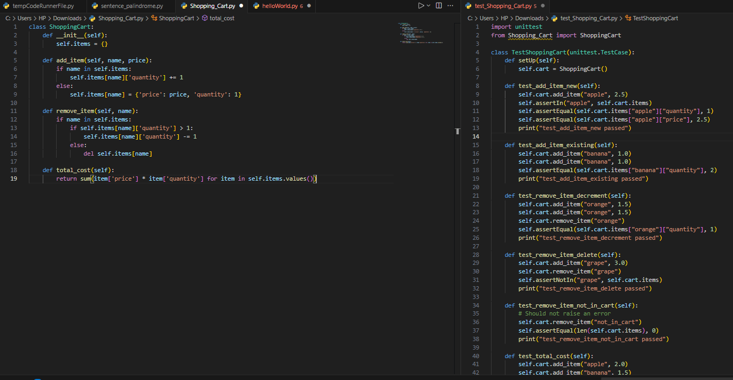

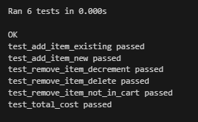

**Task Description#5**

* Use AI to write test cases for convert_date_format(date_str) to switch from "YYYY-MM-DD" to "DD-MM-YYYY".

**Example: "2023-10-15" → "15-10-2023"**

**Expected Output#5**

* Function converts input format correctly for all test cases

